Catholicmessage.org

03.01.2022
Головна » 2020 » Октябрь » 21 » Is Fr. Khoat V. T. a Valid Priest?

16:37
Is Fr. Khoat V. T. a Valid Priest?
Is Fr. Khoat V. T. a Valid Priest?
(Fr. Khoat V. T., Archbishop Lefebvre and 'Sedevacantist' Bishops)
Actually, I propose to readers to find a correct answer to the three following questions:
- Is Fr. Khoat V. T. a valid priest?
- Is Fr. Khoat V. T. a valid bishop?
- Are the 'sedevacantist' bishops consecrated by Bishop Thuc valid bishops?
In 1978, Fr. Khoat was "excommunicated" by the novus ordo bishop of Beaumont, Texas after he (Fr. Khoat) joined the Traditionalist Society of St. Pius X (SSPX) founded by the French Archbishop Marcel Lefebvre in 1970. All the clergy of the Society were suspended from their public duties by the Vatican II in 1976. Archbishop Lefebvre, however, continued to travel and meet his followers and supporters in Europe and the Americas. On August 12, 1979, he came to Fr. Khoat’s Vietnamese community and blessed their church in Port Arthur.
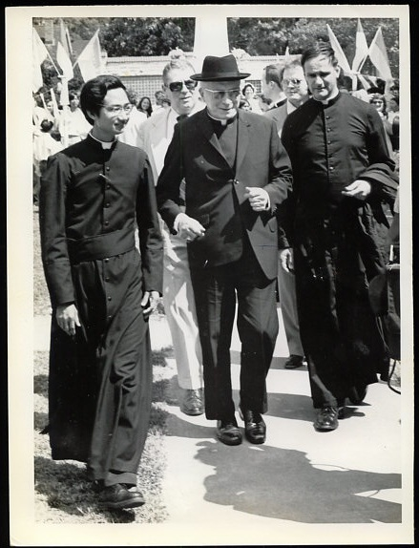
This picture was taken when Abp. Marcel Lefebvre visited Fr. Khoat Van Tran's Vietnamese community in Port Arthur TX, August 1979 A.D., accompanied by SSPX priest Fr. Hector Bolduc.
The same picture can be seen in Fr. Cekada's video of Feb. 27, 2016 "Marcel Lefebvre: Sedevacantist" (See 8:03)
Here is the report about that event by The ANGELUS (SSPX periodical) which is more than convincing proof that Fr. Khoat recognized Archbishop Lefebvre as a valid bishop:
September 1979
VIETNAMESE RESURRECTION
On the afternoon of Sunday, August 12th, Archbishop Marcel Lefebvre, accompanied by Fr. Hector Bolduc, a seminarian, and a few parishioners from Queen of Angels in Dickinson, Texas, arrived in a small rented plane at the Beaumont–Port Arthur airport. Due to the Archbishop's delayed arrival in Houston, Father Bolduc had called ahead to insist that a single car meet the Archbishop at the airport. As the plane taxied to a halt, Father said he hoped they were waiting. Others looked out the windows at the crowds gathered along the fence. "I wonder what they're waiting for," someone remarked. Someone else noticed that a great number of cars in the vast parking lot had flags flying from their antennas. "Aren't those yellow and white ones Papal flags?" Archbishop Lefebvre smilingly began to wonder what sort of reception awaited him. As he descended from the plane, Vietnamese Father Peter Tran van Khoat advanced with several of his parishioners to greet His Grace. They led him to a waiting car, decked with American, Vietnamese and Papal flags. Since the car could not hold the entire party, others were ushed into a waiting police car. As the cars moved away, so did dozens of others, forming at last an impressive motorcade of about seventy-five vehicles, all adorned with flags. The police escort led the procession with flashing lights, blocking intersections and even the expressway for the long line of cars to move ahead unobstructed. As the Archbishop's car arrived in front of the Vietnamese Resurrection Church in Port Arthur, the crowd of parishioners gathered on the sidewalk and the lawn burst into thunderous applause. The elders of the community, dressed in their blue ceremonial robes, beat upon huge gongs. Reporters surrounded Archbishop Lefebvre as Father Khoat led him towards the buildings, when suddenly the deafening blast lasting several minutes from strings of hundreds of firecrackers put an end to all questions and conversation. His fatherly heart moved by this enthusiastic display of affection, the Archbishop stood smiling in the doorway for some time, greeting the Vietnamese parishioners and their families and blessing the little children.
The local diocese several years ago had sponsored the courageous flight of these Vietnamese from their native land. Originally the bishop had intended for them to be absorbed into various parishes. But he had not reckoned with their spirit of unity, and once in the United States, they preferred to continue to live together. Besides, the liturgical and other antics in their new Texas parishes disgusted them and left them feeling lost.
So under the guidance of Father Peter Khoat, the Vietnamese decided to form their own parish. They bought and refurbished a former Baptist Church in Port Arthur that can seat several hundred people. Furthermore, Father Khoat continued to offer only the traditional Catholic Mass. The affection of the local bishop for the immigrants he had sponsored diminished rather drastically. All federal aid to the refugees was being channeled through the diocese, and with the sort of "charity" we have become accustomed to in the Conciliar Church, the bishop cut off all funds and all other aid to the loyal parishioners of Father Khoat. Despite various hardships, this very industrious people found employment principally as fishermen, and quickly endeared themselves both to their employers and fellow citizens. This summer they learned with joy that Archbishop Lefebvre would respond to their invitation by coming to bless their church on August 12th.
After vesting in the sacristy, the Archbishop, assisted by Father Bolduc and Rev. Mr. Laudenschlager, proceeded to the front doors of the church to begin the ceremony. After a prayer, he went around the outer walls of the edifice blessing them with holy water. The clergy and people then entered the church and knelt before the altar during the singing of the Litany of the Saints. The blessing of the inner walls of the Church in the same manner followed.
The administration of the Sacrament of Confirmation to ninety-three children preceded Pontifical Mass, at which Archbishop Lefebvre preached in French (Father Bolduc translated into English and then Father Khoat into Vietnamese). At the end of the Mass, according to Vietnamese custom, the men of the community came forward to take an oath of fidelity to the Church before the altar in the presence of the Bishop. His Grace then distributed ornate scrolls to them in remembrance of the solemn occasion.
The intense Texas heat and the quick change from mid-winter weather in Argentina had left the Archbishop somewhat tired, but Father Khoat's devoted women parishioners promptly provided a remedy: a delicious meal of elegantly prepared Vietnamese dishes and cool drinks. Meanwhile, charmingly dressed little girls from the parish performed folk dances for his entertainment. Soon, however, His Grace had to leave to return to Queen of Angels, physically tired but refreshed and gratified by the boundless enthusiasm and the heartwarming reception given him by these devout Vietnamese Catholics. And certainly they will never forget the grace-filled visit to their flourishing parish of a true successor of the Apostles.

